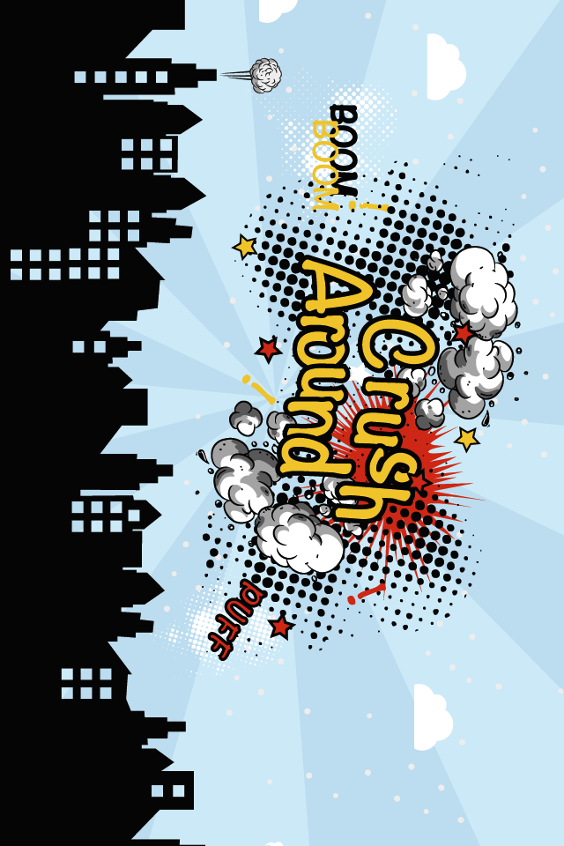**Image Processing on Mobile Platforms – Final Project:   
Crush Around**

**By**

**Ziv Levy,** [**levy.ziv@post.idc.ac.il**](mailto:levy.ziv@post.idc.ac.il)**, ID: 036574226**

**Tomer Cagan,** [**cagan.tomer@post.idc.ac.il**](mailto:cagan.tomer@post.idc.ac.il)**, ID: 035944107**

**Introduction**

**Crush Around** is Augmented Reality game in which the player interacts with its environment – destroying it as the game progress.   
Usually, mobile games separates the player from his surrounding and his peers. Crouching on top of the mobile device, the player is isolated.   
But it doesn’t have to be that way... **Crush Around** lets the user play in its surrounding by augmenting a game layer on top of the real world which encourages him to open up to the world. By viewing the real world via camera, the player has to react to its environment. No more crouching on top of the device.

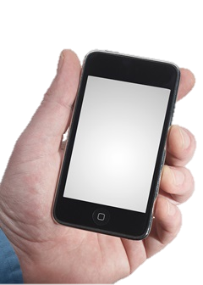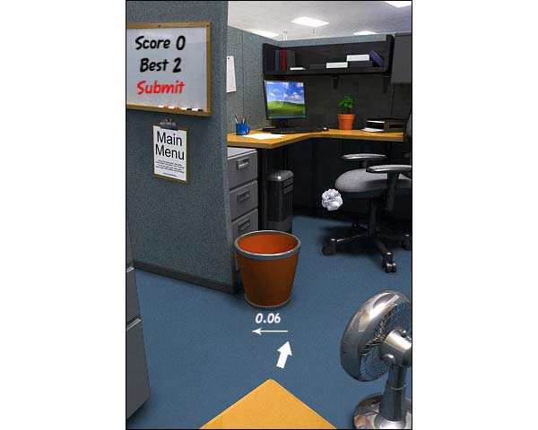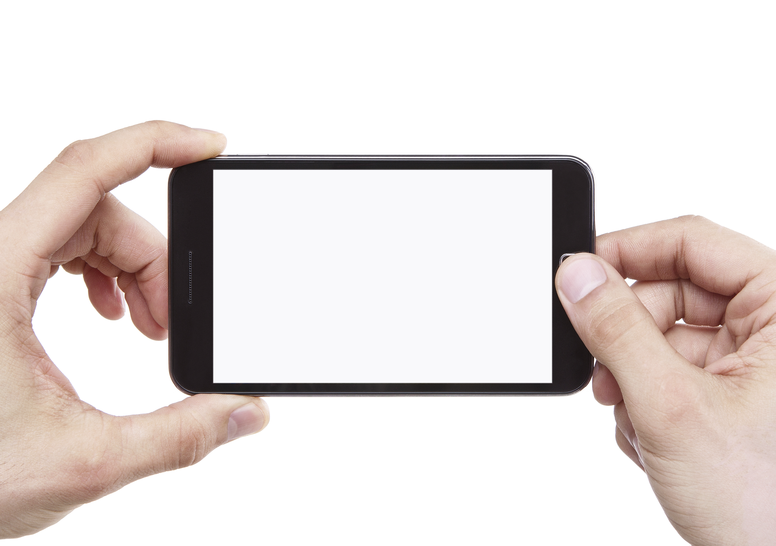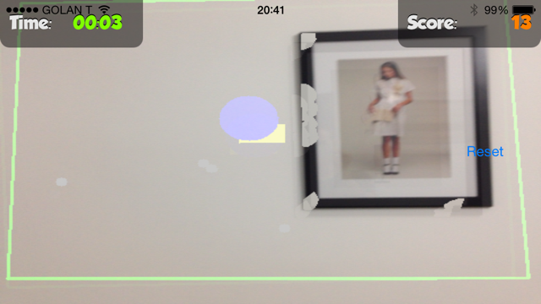

In addition, by playing in the real world, the game is meaningful not only to the player but to other people by sharing the game play epic achievements or collaborating with others in wreaking havoc.

**Game Interface**

In **Crush Around** the gamer points the mobile device camera onto the scene.

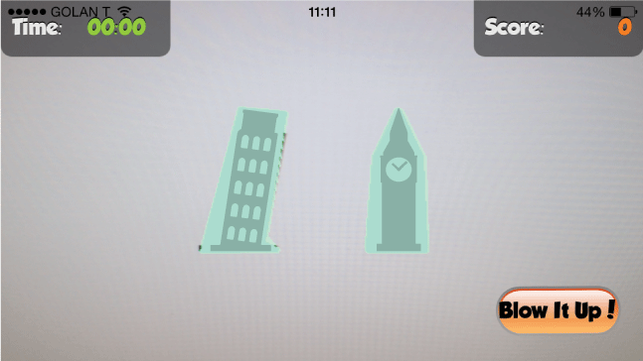

The game automatically detect objects in the surrounding, transforming the scene into a game level in which the player can interact by bouncing a ball around (similar to classic “Wall Breaker” games).

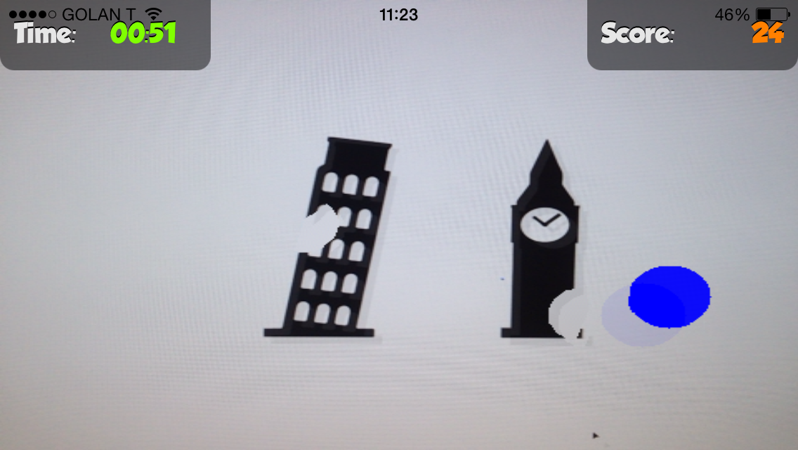

The more destruction – the more points (and fun). Several game mechanisms ensure that the gamer faces dilemas and tension, which makes the experience more rewarding.

All the game core and image processing classes are written in C++, uses [OpenCV](http://opencv.org/) and [Box2D](http://box2d.org/) – open source C++ libraries for Computer Vision and physic simulation so this is successfully working on multiple platforms such as iOS, Android and Win32.

**Image Processing Tools and Implementation**

*** Diagram goes here ***